Prepositional Object

✅ What Is a Prepositional Object?
# Source: Chatbot (GPT-4-turbo) at [8/4/2025]
A Prepositional Object is the noun, pronoun, or noun phrase that follows a preposition and completes its meaning.
It is the object of the preposition, not of the verb directly.

🔸 Key Features:
# Source: Chatbot (GPT-4-turbo) at [8/4/2025]
- Always follows a preposition (e.g., in, on, at, under, with, to, about, for).
- Forms a prepositional phrase: preposition + object.
- The object can be:
  - A noun: in the room
  - A pronoun: with him
  - A noun phrase: under the old wooden bridge

🔸 Examples of Prepositional Objects:
# Source: Chatbot (GPT-4-turbo) at [8/4/2025]
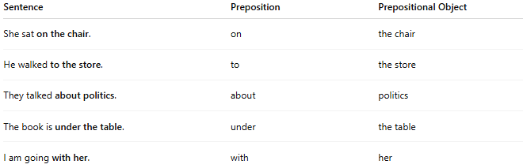
Sentence | Preposition | Prepositional Object
She sat on the chair. | on | the chair
He walked to the store. | to | the store
They talked about politics. | about | politics
The book is under the table. | under | the table
I am going with her. | with | her

🔸 Quick Test:
# Source: Chatbot (GPT-4-turbo) at [8/4/2025]
Ask:
- What follows the preposition?
- What is the preposition referring to?
Example:
- “He looked at the painting.”
→ Preposition: at
→ Object of preposition: the painting ✅

